U.S. Student Aid Database Schema and Query Recommendations

Shane Ẽire Byrne

DAT390

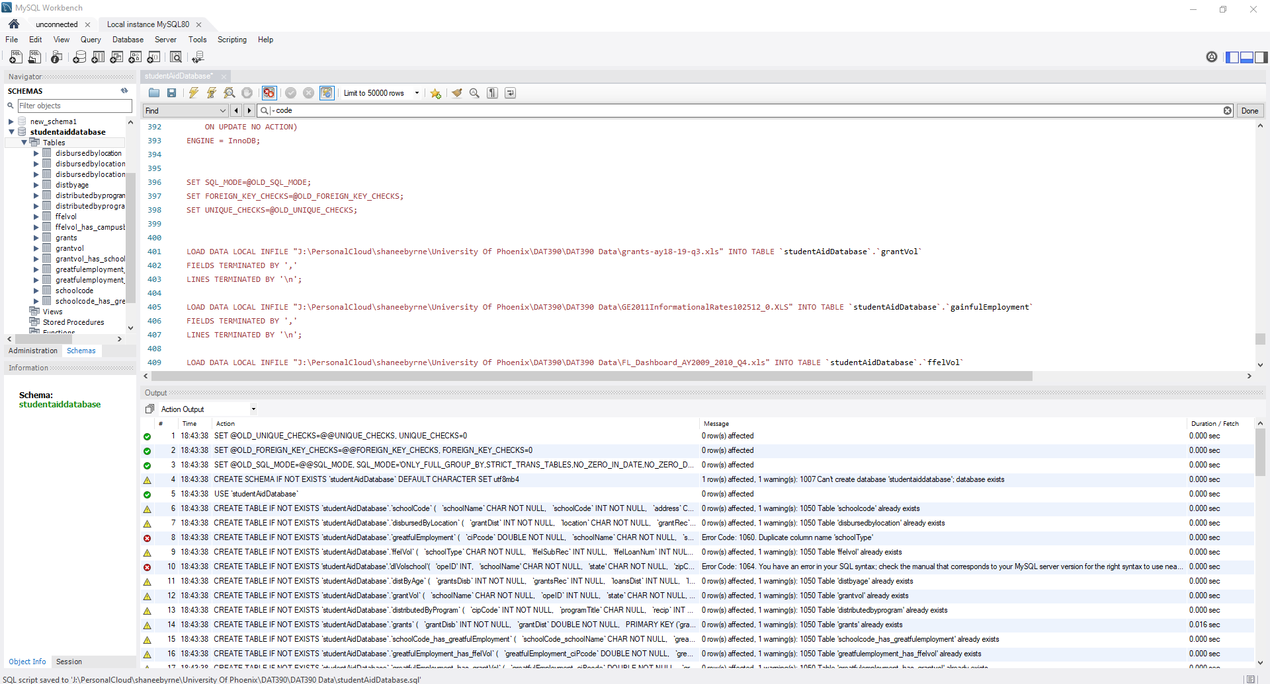

The underline schema of this database would allow one in theory to tabulate data from various collegiate insitituions and populate the data into an arranged set of tables presented as a database. While it is not fully operational and still has bugs to be worked out to allow it to do this, it does exist in structure as a fulldata base. The notion of having MySQL pull data from the Excel worksheets is where the current issue lies.

However while it may not yes successfully connect to the datafiles, it is still a fully constructed schema.

This includes connected tables with primary and foreign keys.

Best practices to emplore in the operation of such a schema would be a simplification of data. The spreadsheets provided as datasets, this would help alleviated the issues brought forth with the poplation of data into the tables from the spreasheets.

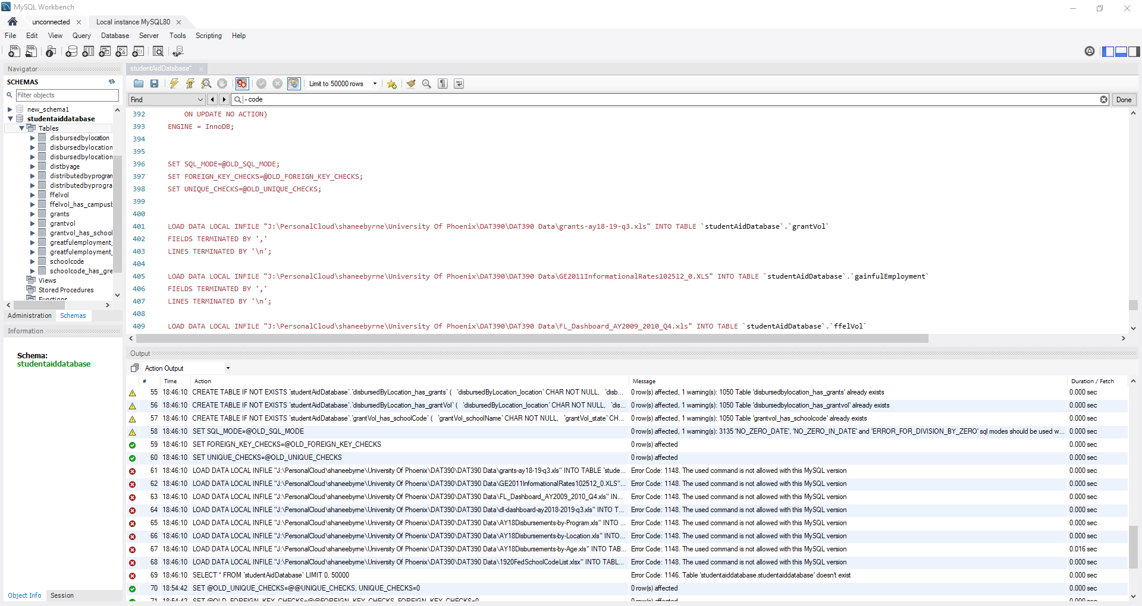

As indicated by the red error markings. 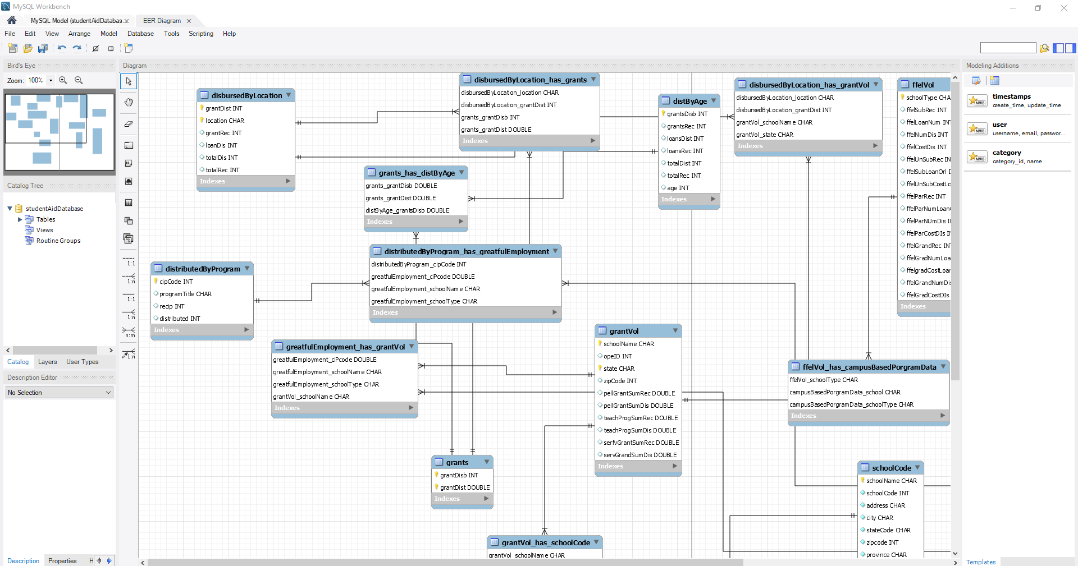

Diagram is a EER Diagram derived from built tables.

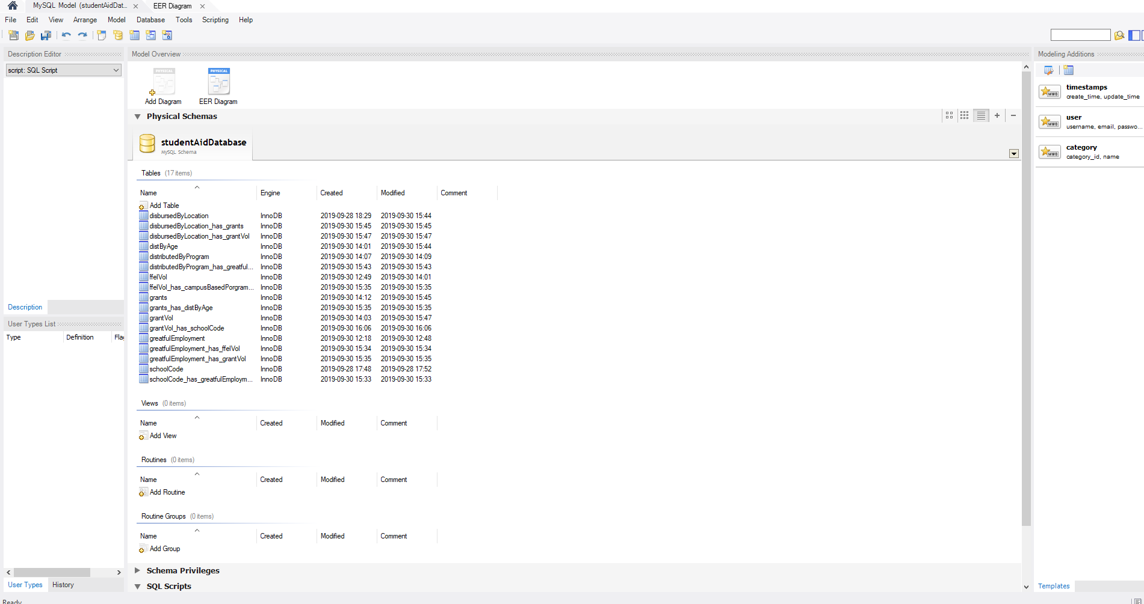

Queries to pull requested data were unsuccessful due to inability to connect data from Excel Spread sheets directly to the tables themselves.

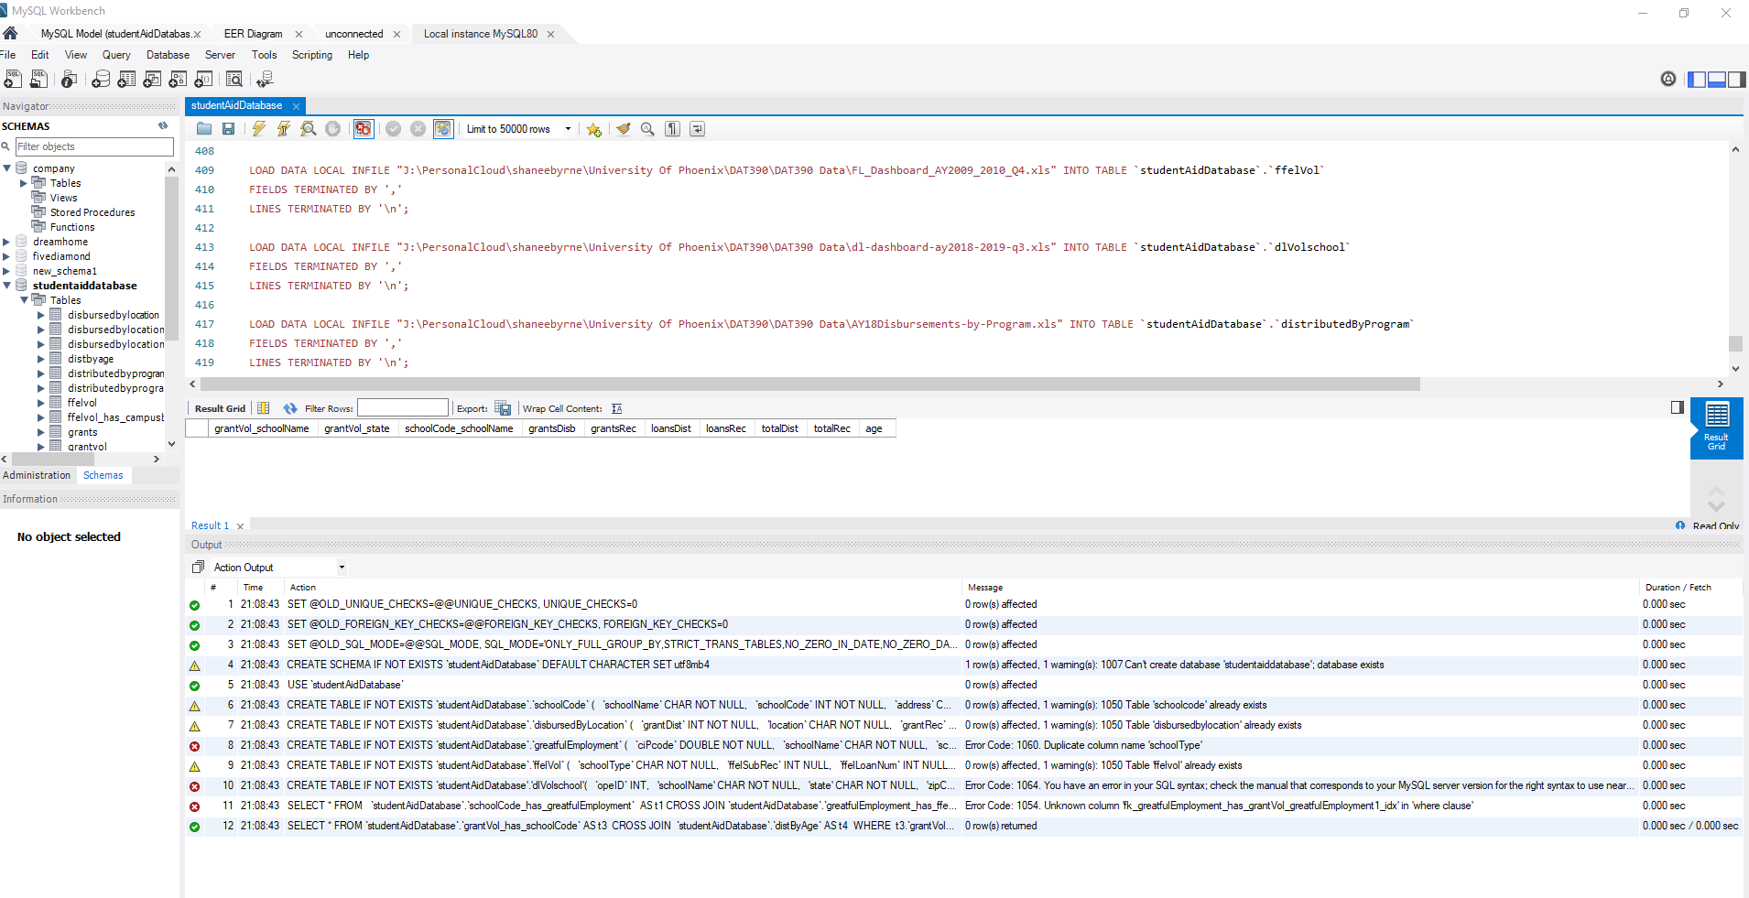

Second Query to pull the highest amount of debt for the average student who attends was successful, however with no attached data there was nothing to calculate. Average found with AVG() function built into MySQL.

**References**

* Cohen, B., Pepi, N., & Mishra, N. (2017). Real SQL Queries: 50 Challanges (2nd ed.).
* Coronel, C., Morris, S. (20160126). Database Systems: Design, Implementation, & Management, 12th Edition [VitalSource Bookshelf version]. Retrieved from vbk://9781337509596
* Murach, J. (2019). Murach's MySQL (3rd ed.). Fresno, CA: Mike Murach & Associates, Inc..
* Short, T. (2016). SQL Beginner to Pro Guide . : DCW Web Trading LTD.
* SQL Quickstart Guide The Simplified Beginner's Guide to SQL . : ClydeBank Technology.
* Tahahhoghi, S. M. M., Williams, H. E., & Oram, A. (2009). *Learning MySQL* . Sebastopol, CA: O'Reilly Media, Inc..
* Tale, S. (2016). SQL The Ultimate Beginners Guide . : Steve Tale. (2016).
* Connolly, T., Begg, C. (01/2014). Database Systems: A Practical Approach to Design, Implementation, and Management, 6th Edition [VitalSource Bookshelf version]. Retrieved from vbk://9781323291511
* Elmasri, R., Navathe, S. B. (05/2017). Fundamentals of Database Systems, 7th Edition [VitalSource Bookshelf version]. Retrieved from vbk://9781323765883